* • **Install Power BI Desktop and share the final screenshot of the report view page which appears when power desktop starts.**
* • Prepare a document and with the following screenshot −
* Report View

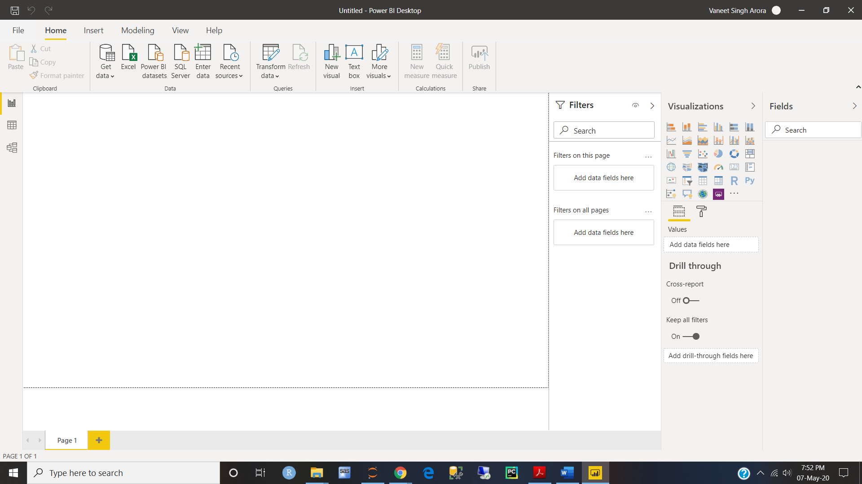

* − Data View

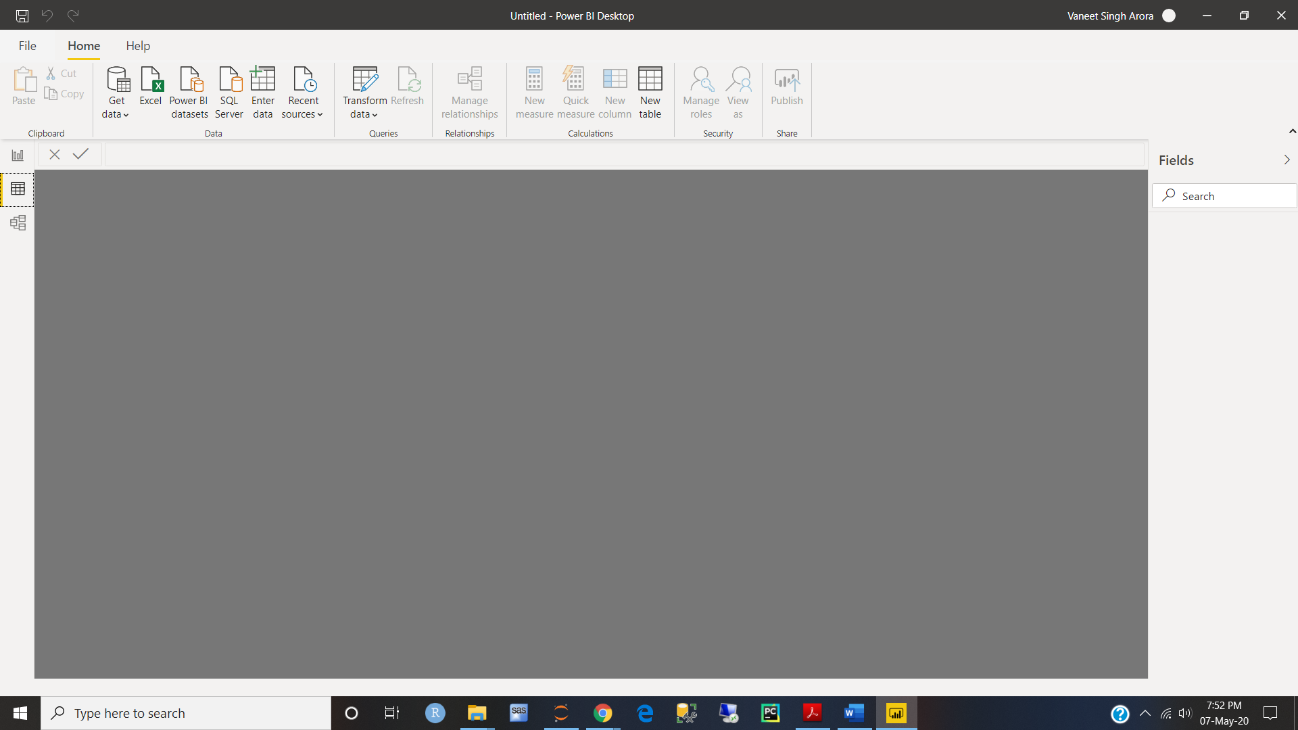

* − Model View

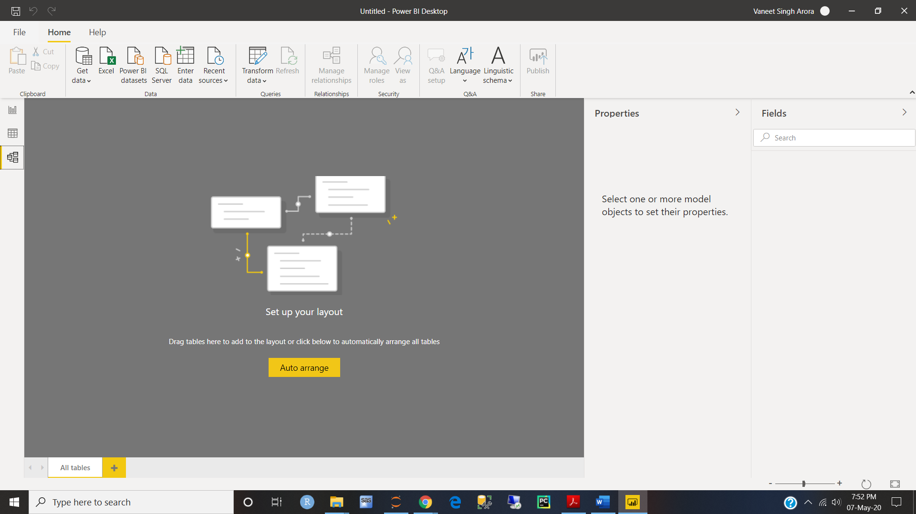

* − Power Query Editor

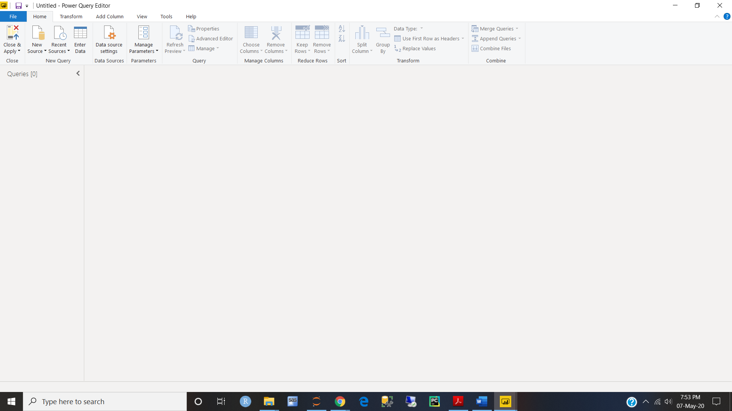

* − Advance Editor

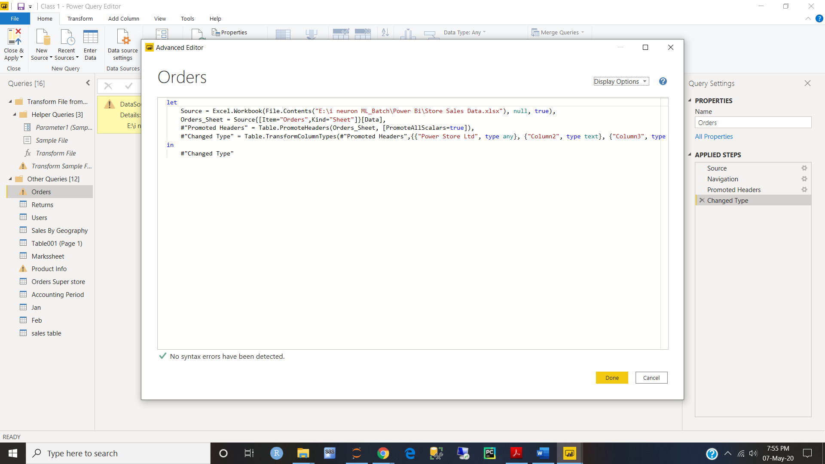

* • Prepare a document with details of the following along with their price

− Power BI Desktop

− Power BI Pro

− Power BI Premium

**Power BI comes in three levels – Desktop, Pro, and Premium. The Desktop level is free for individual users, while the Pro plan costs $9.99 per user per month. The Premium plan starts at $4,995 a month per dedicated cloud compute and storage resource.**

ll of Microsoft Power BI’s functions are built for its three main features:

1. **Datasets**: As defined by Microsoft, “a dataset is something you can import or connect to.” Much like [BIME Analytics](https://www.betterbuys.com/bi/reviews/bime-analytics/), the Power BI solution connects to all of an organization’s data sources, bringing disparate data together in one place. This reduces the time-consuming tasks associated with data capture, access and evaluation, making it easy to identify trends and make business decisions.
2. **Dashboards**: Dashboards are interactive panels that correlate disparate data through smaller displays called tiles. Dashboards are linked to each dataset for comparison and evaluation, and they can be shared with colleagues to easily exchange information.
3. **Reports**: Power BI’s reports can be created from scratch to ensure only critical information is included. These custom reports can be imported to any dashboard for quick, simple sharing among colleagues.

Additional features the solution offers are:

* **Navigation pane**: With the navigation pane, you can smoothly shift through datasets, dashboards and reports.
* **Q&A question box**: The Q&A question box allows you to explore data by asking a question in natural language. The technology uses rephrasings, autofill, suggestions and more to help you find the correct answer the first time.
* **Help & feedback buttons**: These are resource buttons for settings, downloads, getting support and providing feedback to the Power BI team.
* **Office 365 app launcher**: This allows you to quickly open the Office 365 apps you want and need.

